**Aim:** Case study on own cloud

**Steps of Performance:**

**Step 1:** Create a Virtual Machine for Ubuntu 16.04 LTS Desktop on Oracle Virtual Box and Log In to your Virtual Machine:

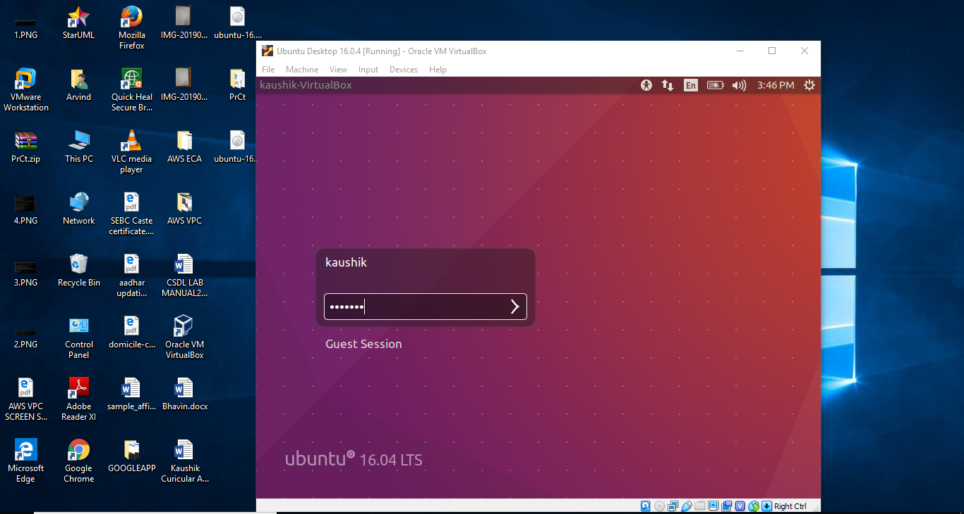

**Step 2:** Right Click and open Terminal. Before we begin, we need to update all the packages, libraries, and repositories installed on our machine by running the following command:

sudo apt-get update

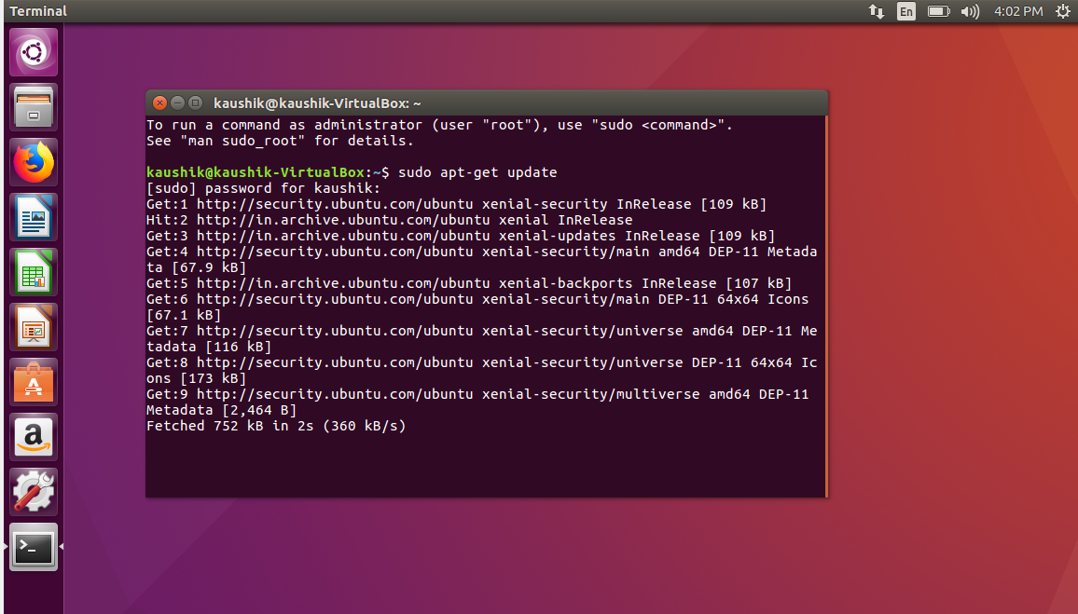

**Step 3:** In order to serve the client requests, you may require LAMP Server. LAMP Server is a Web Development Platform for Linux and stands for **L**inux **A**pache **M**ySQL **P**HP. Install LAMP Server using the following command:

sudo apt-get install lamp-server^

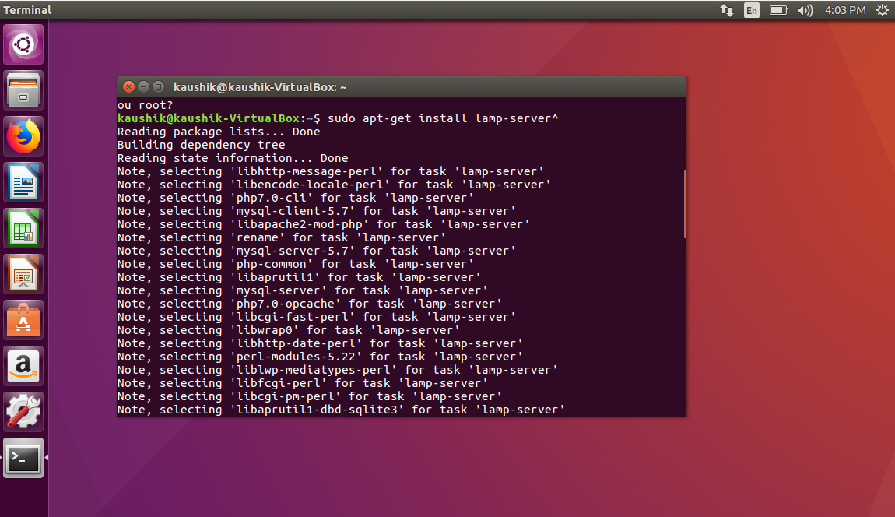

**Step 4:** The Release Key for ownCloud need to be downloaded which are stored in the cURL library. So, first install cURL in your system by running the following command:

sudo apt-get install curl

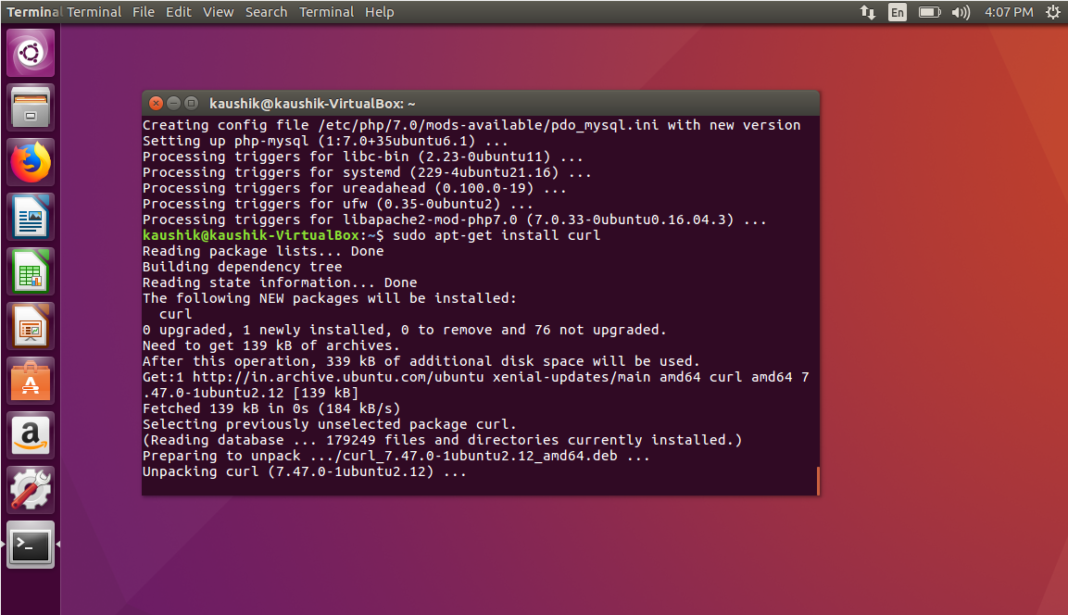

**Step 5:** Now, download the release key of ownCloud using the curl command and import it with the apt-key utility with the add command:

sudo curl [https://download.owncloud.org/download/repositories/stable/Ubuntu_16.04/Release .key](https://download.owncloud.org/download/repositories/stable/Ubuntu_16.04/Release%20.key) | sudo apt-key add -

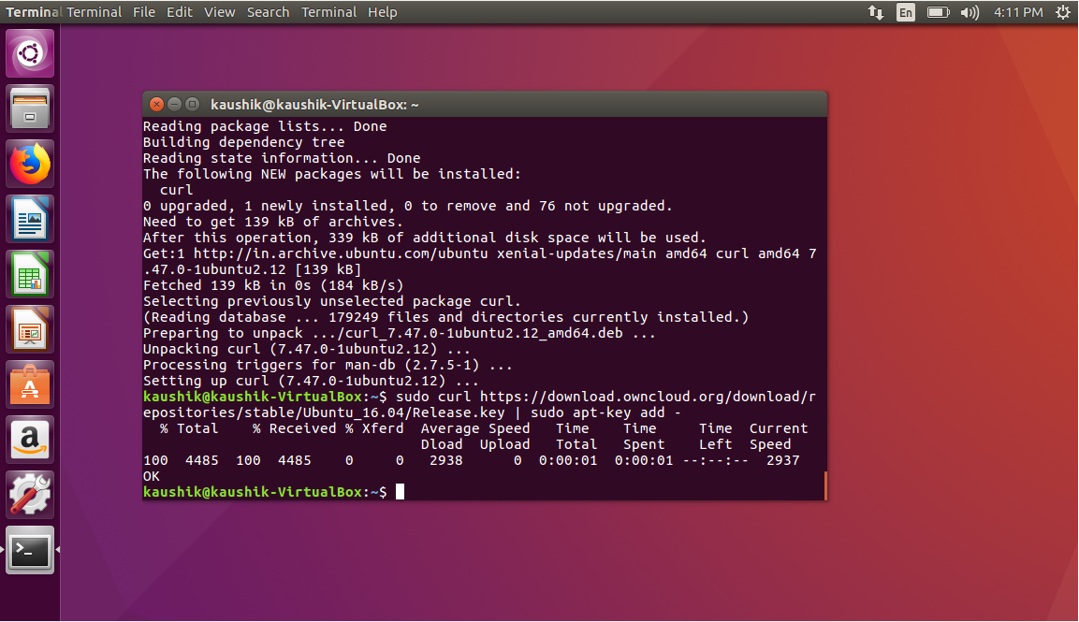

**Step 6:** The 'Release.key' file contains a PGP (Pretty Good Privacy) public key which apt will use to verify that the ownCloud package is authentic. The following command will import the downloaded Release key. In addition to importing the key, create a file called owncloud.list in the sources.list.d directory for apt. The file will contain the address to the ownCloud repository:

sudo echo 'deb http://download.owncloud.org/download/repositories/10.0/Ubuntu_18.04/ /' | sudo tee /etc/apt/sources.list.d/owncloud.list

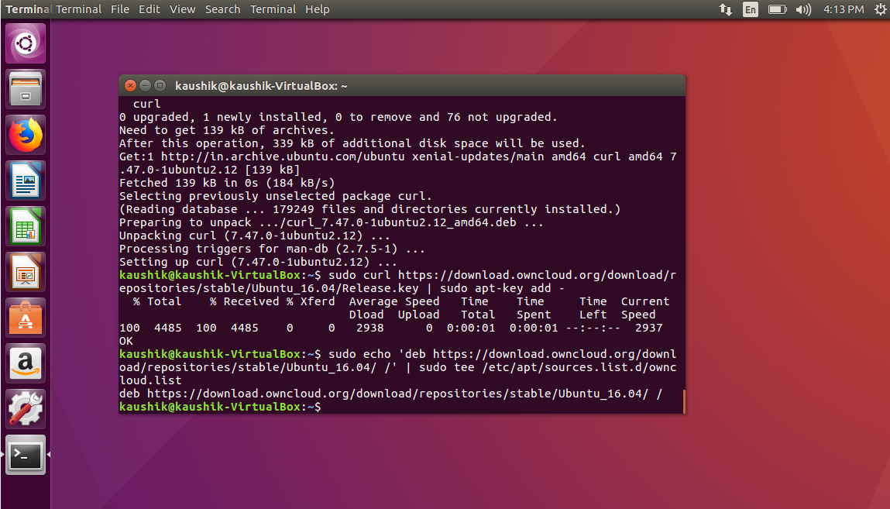

**Step 7:** Install all the required packages, libraries and files for ownCloud by running the following commands one by one on terminal:

1. sudo apt-get install owncloud-files

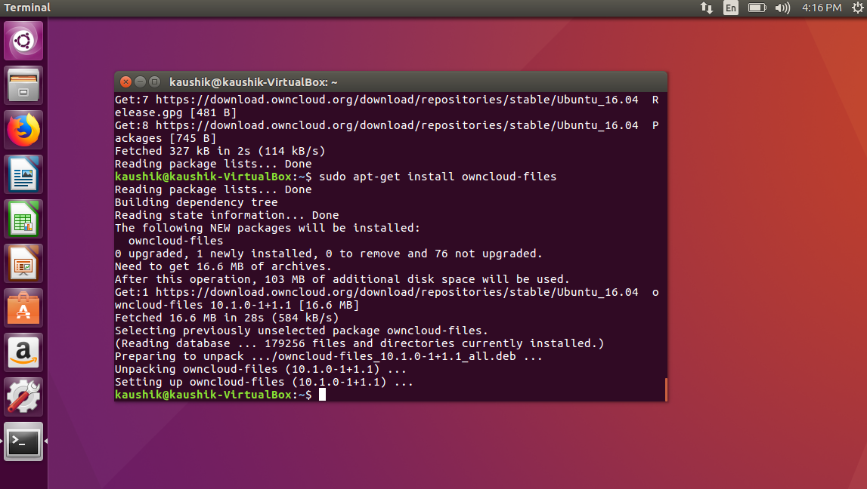

1. sudo apt install -y apache2 mariadb-server libapache2-mod-php7.0 \ php7.0-gd php7.0-json php7.0-mysql php7.0-curl \ php7.0-intl php7.0-mcrypt php-imagick \

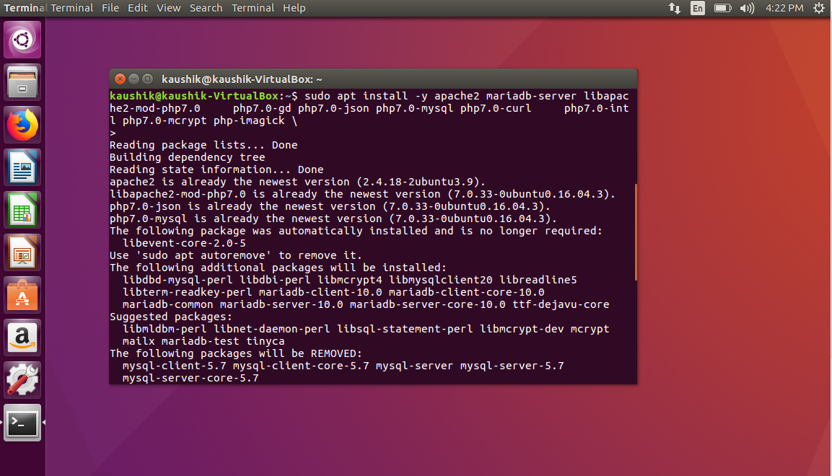

1. sudo apt install -y php7.0-zip php7.0-xml php7.0-mbstring

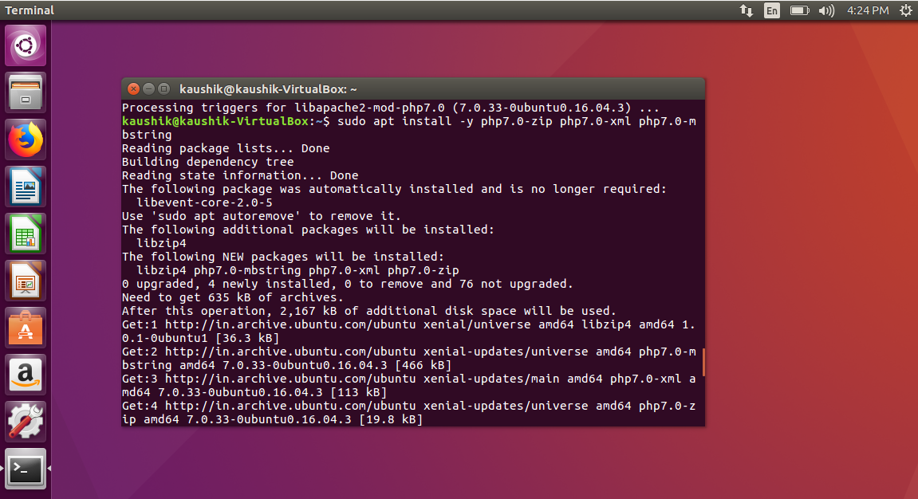

**Step 8:** Now, we need to make sure that all the installed packages are successfully detected and read by the Apache Server. So, to restart Apache Server, execute the following command:

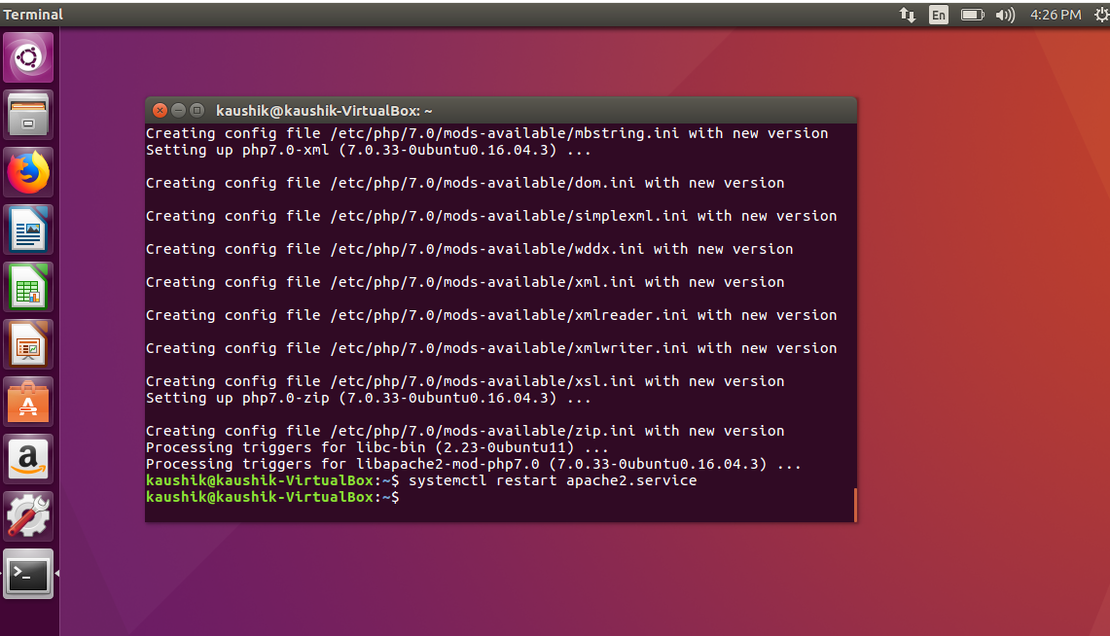

**Step 9:** Here, we have completed the configuration of Apache Server and ownCloud packages. The next step is to configure the Database for ownCloud. To open the MySQL prompt or MariaDB prompt, type in the following command:

sudo mysql –u root -p

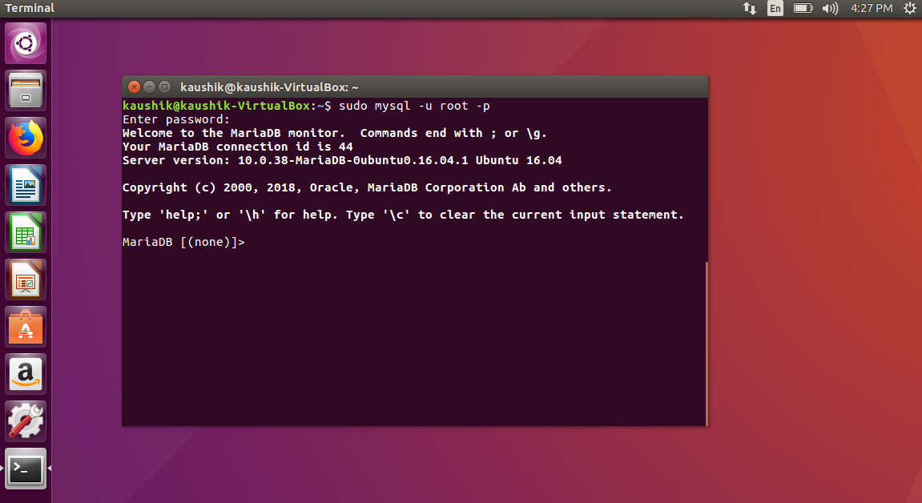

**Step 10:** To create a database named “owncloud”, execute the following SQL query on the MariaDB prompt. NOTE that your query is succeeded by a SEMI-COLON(;) :

CREATE DATABASE owncloud;

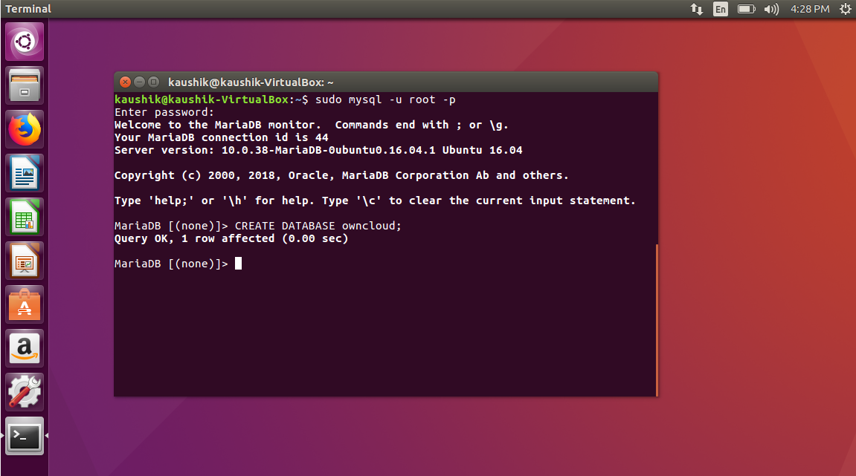

**Step 11:** Next, we need to configure a “user”, that is an admin account for ownCloud and grant him privileges to perform all operations on the database named “owncloud” that we had created previously. In our example, this admin user is given the same name as the database, that is “owncloud”. The following command creates a user named “owncloud” and grants him all privileges on the database named “owncloud”. Also, the password of the user, “kaushik” in our case is verified by using the “IDENTIFIED BY” sub-query:

GRANT ALL ON owncloud.* to ‘owncloud’ @ ‘localhost’ IDENTIFIED BY ‘kaushik’;

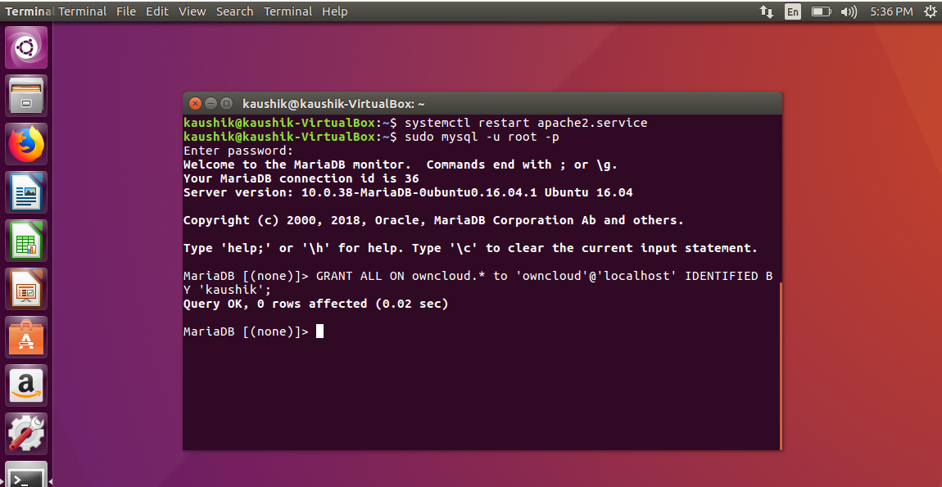

**Step 12:** Finally, as all our query execution is done, we flush all the previous privileges and exit the MariaDB prompt by running the following command:

FLUSH PRIVILEGES;

exit;

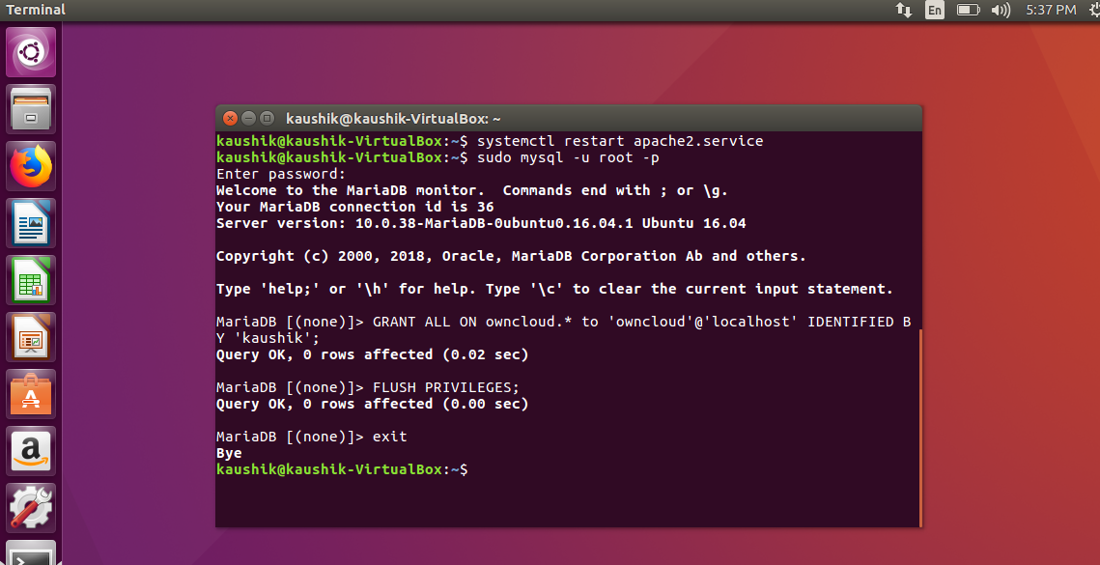

**Step 13:** Earlier, owncloud files were all downloaded in the default localhost folder /var/www/html. But now, since the new custom patch for owncloud has been released, the files are downloaded in /var/www folder. On Linux Ubuntu 16.04, this creates errors. So, copy the owncloud directory to its original location using the following commands:

cd /var/www

sudo cp –R owncloud html

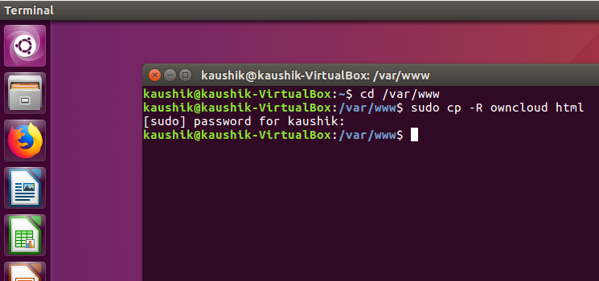

**Step 14:**Now, in Linux Ubuntu, only root user has the permissions to make changes to existing files and directories. The Apache HTTP user, who is not a root user, needs to be given Strong Directory Permissions so that the HTTP server can make changes to the owncloud files when required. The HTTP user and HTTP group for Ubuntu is “www-data”. So, give Strong Directory Permissions to the “www-data” by running the following commands:

sudo chown –R www-data:www-data /var/www/html/owncloud/

sudo chmod –R 755 /var/www/html/owncloud/

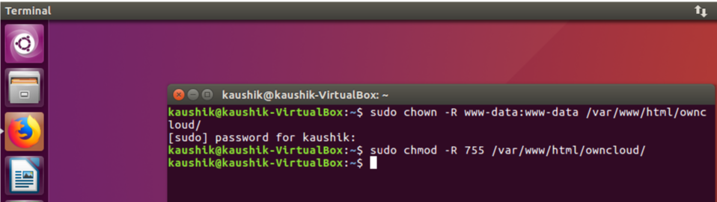

**Step 15:** Now, we are all set to launch ownCloud in our Web Browser. But first, we need to get the IP address of our Ubuntu machine, that is, the address of our localhost. The ifconfig command can be used to determine the IP address of our machine. In our case, the IP address turned out to be 192.168.0.107:

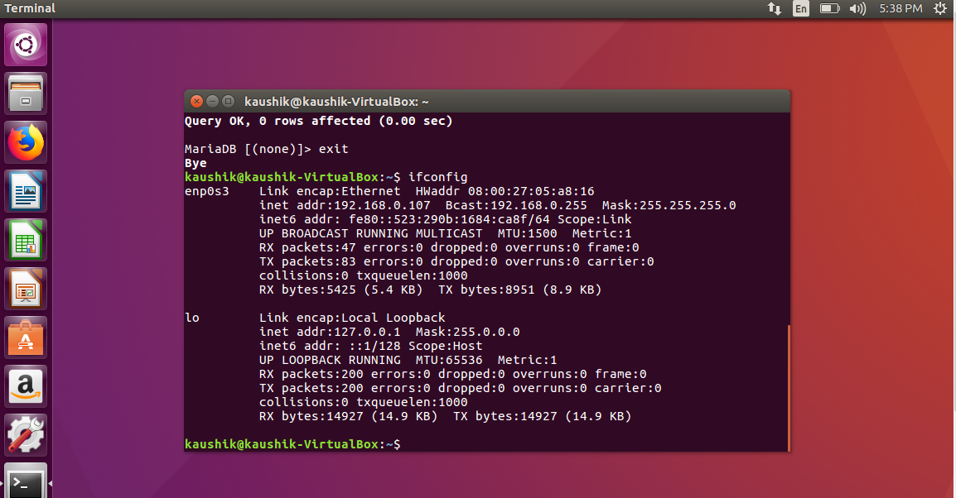

**Step 16:** Now, open your Web Browser and type in the following URL:

localhost/owncloud

In our example, it is 192.168.0.107/owncloud

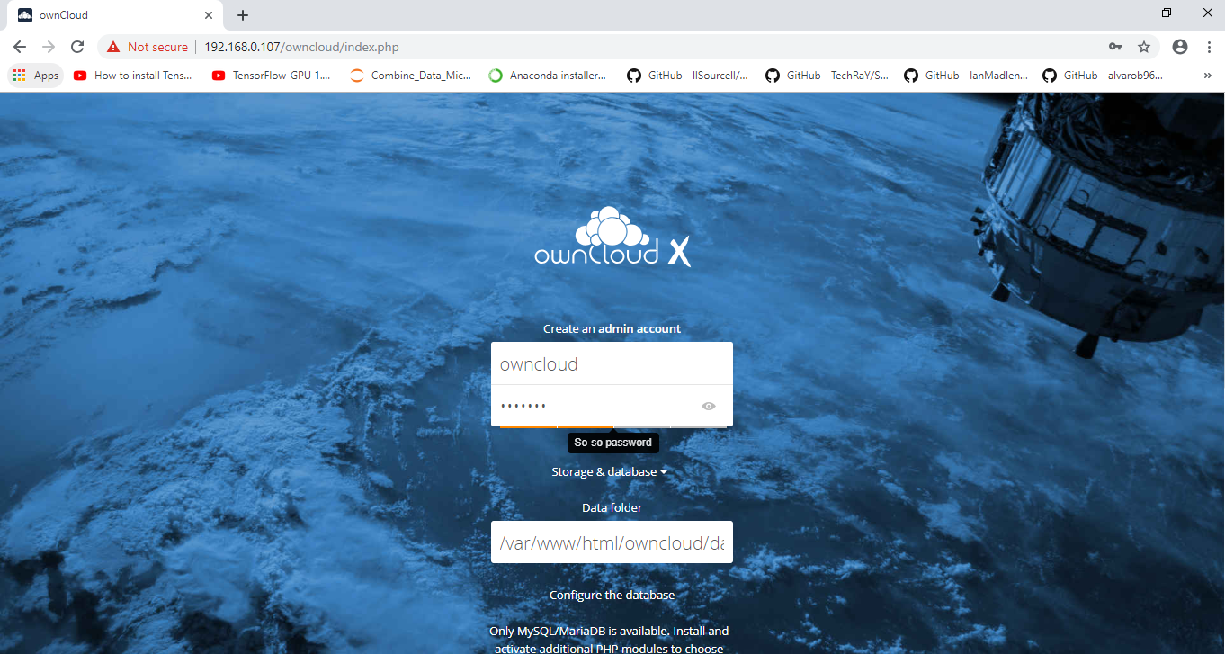

**Step 17:** Now, enter the admin username and password and the database name and password, which we had provided while executing SQL queries on MariaDB. After that, click on Finish Setup:



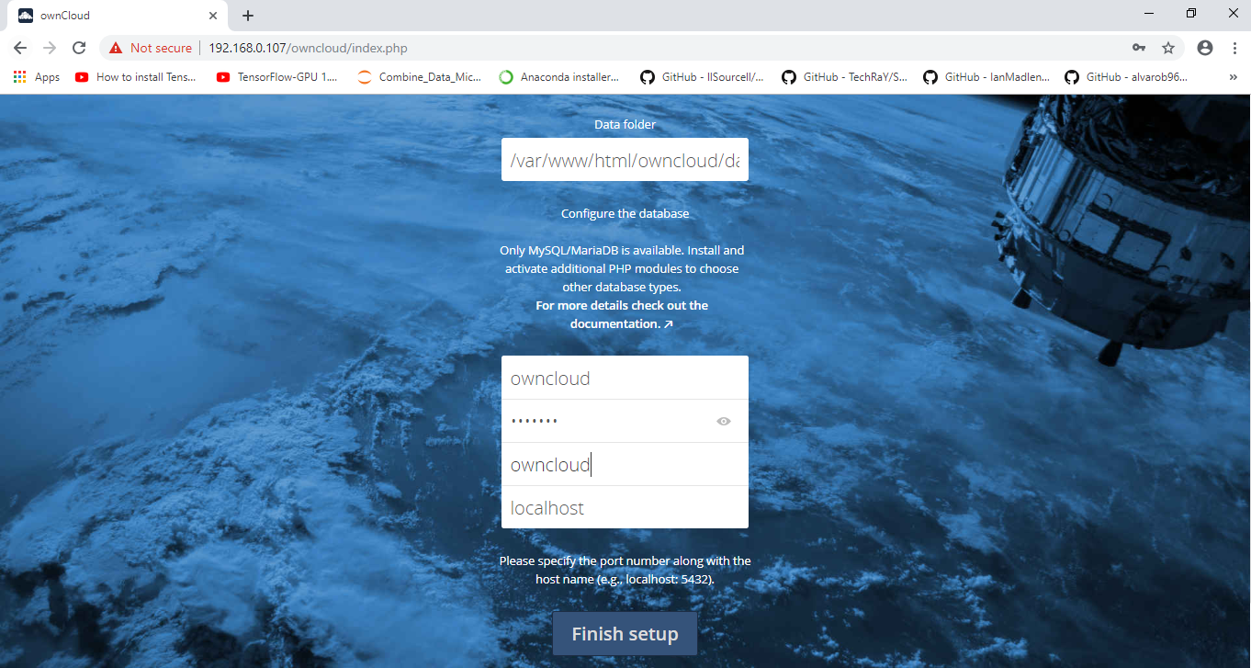

**Step 18:** Log in to ownCloud using the credentials that you just provided:

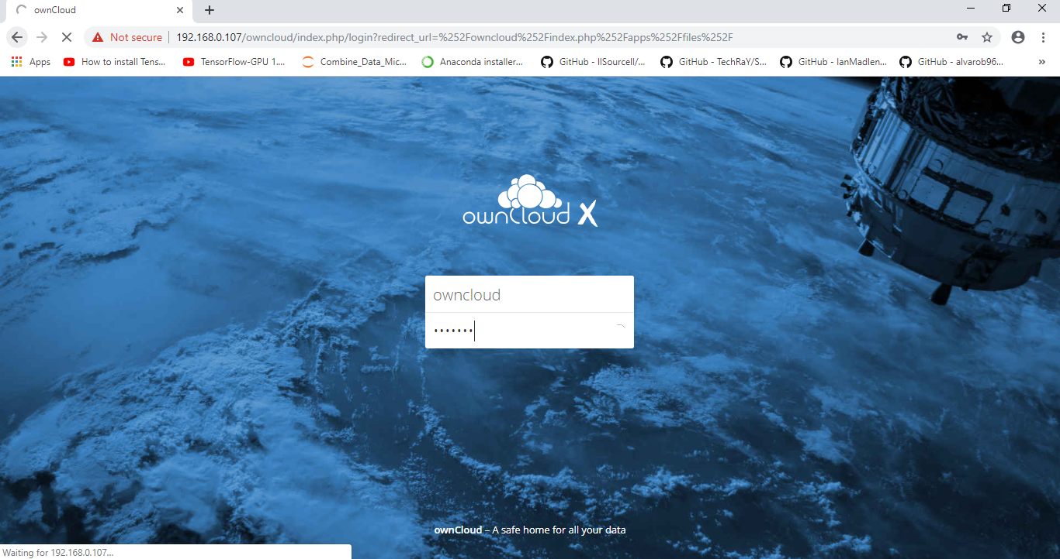

**Step 19:** Congratulations, we have successfully configured and set up ownCloud which can be accessed by our host machine as well as our virtual machine!!!

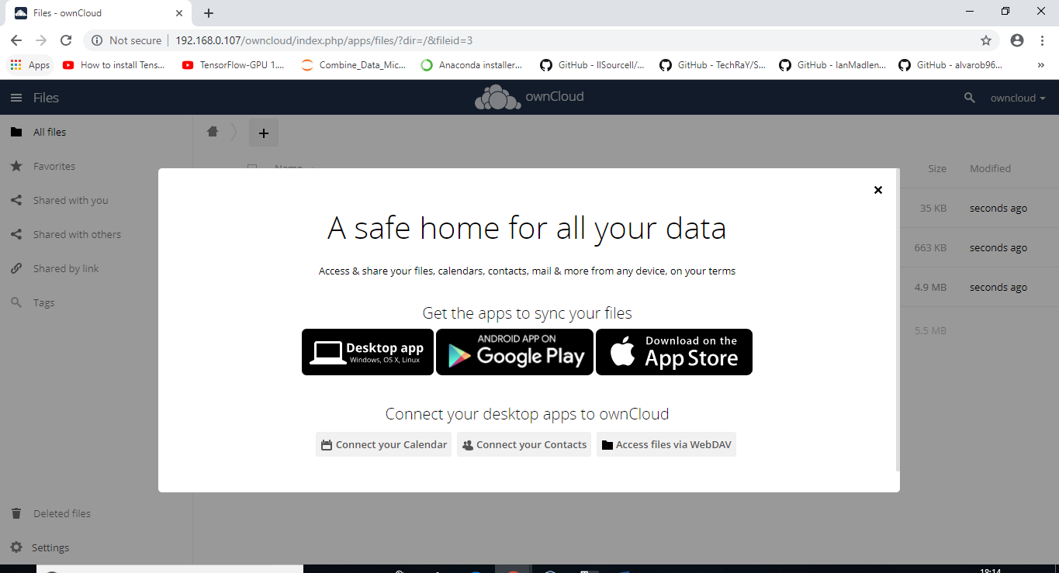

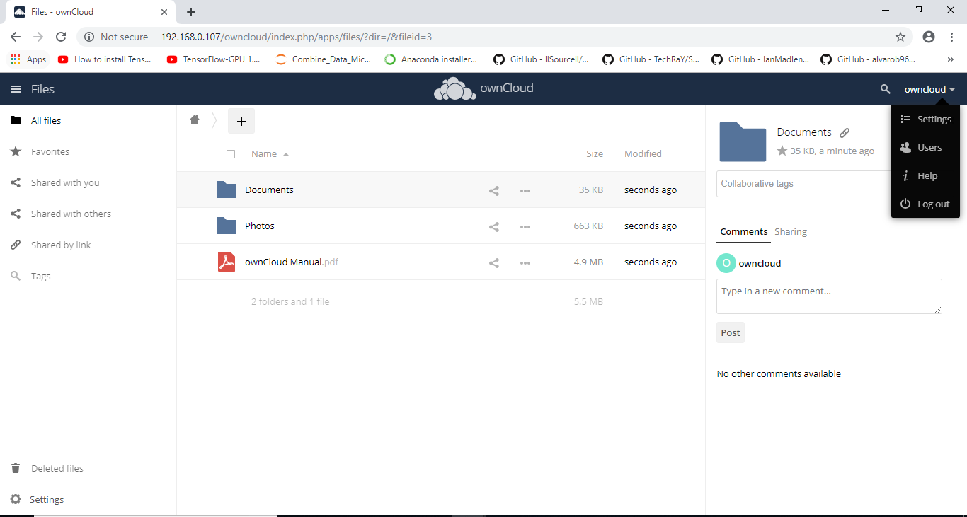

**Conclusion:** In the assigned lab work, various functionalities of the ownCloud were studied. Initially, a Virtual Machine of Ubuntu 16.04 LTS was created on top of Windows 10 Host Machine. On this Virtual Machine, LAMP Server, MariaDB, and ownCloud were installed and configured successfully.